Cyber Simulation Exercise Report Sample

Executive Summary

Describe the exercise and activity at a high level, along with a brief summary of the findings to enable a quick read with details below for those interested in reading further…

Simulation Exercise Details

Exercise Objective
Simulation exercise object goes here

Exercise Lead and Team
This exercise was led by <name of exercise lead, title, department>

The exercise team consisted of:
<name of team member, title, department>
<name of team member, title, department>
<name of team member, title, department>
…

Exercise Scenario
Simulation exercise scenario goes here

Inject Development Details
Discuss the development of the events/injects
For example:
Developed injects based on detailed descriptions of organizational processes utilizing input from exercise team members regarding their functional areas and processes
- <SPECIFIC NUMBER> of independent injects used for the simulation
- Each inject consisted of multiple parts
- Simulated injects sent from Exercise Lead/ Planner
- Meant to mimic real breach scenarios
- Injects clearly marked EXERCISE, so recipients would not be confused

Exercise Execution
Discuss the start and end time of the exercise
Detail the kick-off inject

For example:
The exercise began 9am on Monday 9-5-19 with INJ-01-01
- INJ-01-01 - is a complaint from customer XYZ regarding a malfunctioning product ABC
- The exercise continued over a 3-day period, ending on Thursday 9-8-19
- Additional details regarding exercise execution

Process Issues/Gaps Identified
Discuss the results of the exercise in terms of process gaps identified (use charts/graphs when possible)

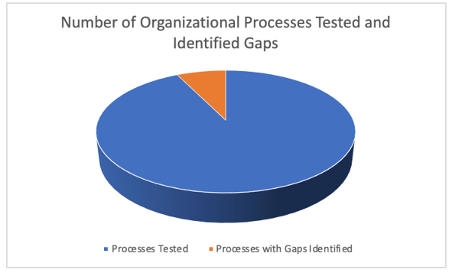
For example:
- Formal process gap in the communication of security incidents from receivers (customer-facing organizational functions) to internal cybersecurity team for further investigation
  - No formal method to discern security incidents from general customer complaints

Summary/Next Steps
Summarize the exercise and discuss the plan to address the gaps from the previous section. Can be modified depending on the audience being addressed.

Ken Zalevsky
CEO, Vigilant Ops
Former Head of Medical Device Cybersecurity, Bayer

Founded in 2019, Vigilant Ops is an innovator in the medical device cybersecurity industry. Led by seasoned medical device cybersecurity experts with more than forty years of combined experience, Vigilant Ops provides medical device manufacturers and hospitals with unprecedented insight into device risk profiles, enabling proactive management of threats before they impact the quality of patient care.

For more information about Vigilant Ops or the InSight Platform, please visit our website at www.vigilant-ops.com
Or drop us an email at: inquiries@vigilant-ops.com

